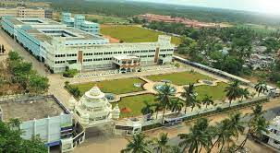

*3+ Interviews Experts*

*+1 Personal Feedback*

**23**

**YEARS**

OF VALUE



[WWW.Kcet.in](http://WWW.Kcet.in)

Want to **CRACK** the **INTERVIEW**..?

**MOCK INTERVIEW DAY**

Date: 09/12/2023

Time: 10 am – 4 pm

Venue: A-Block Seminar Hall

**KRISHNASAMY**

COLLEGE OF ENGINEERING & TECHNOLOGY

*(Approved by AICTE & Affiliated to Anna University - Chennai)*

*Anand Nagar, Nellikuppam Main Road, S. Kumarapuram, Cuddalore – 607 109.*

**Sessions:**

* Technical Round
* Group Discussion
* F2F Interview

Organized by TRAINING AND PLACEMENT CELL